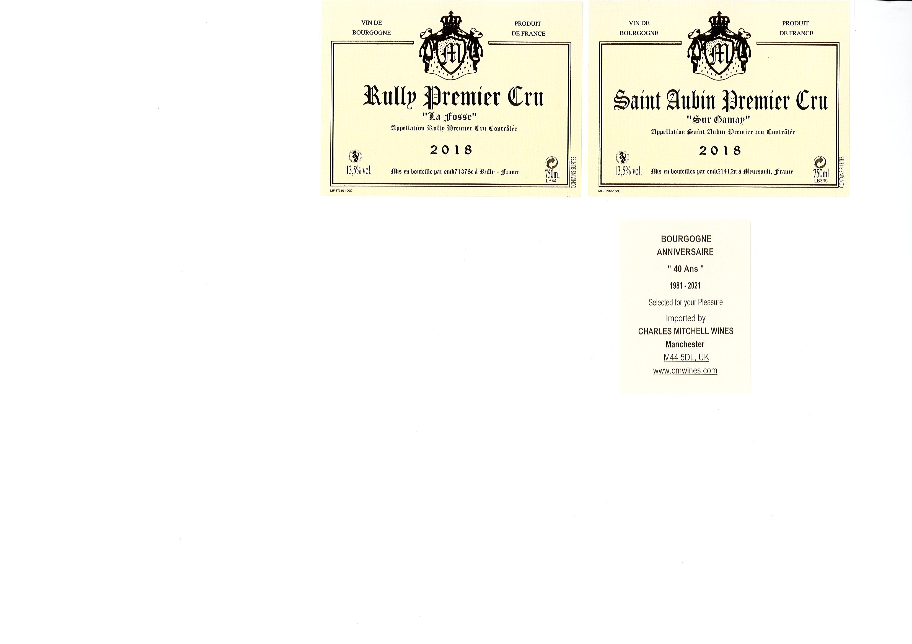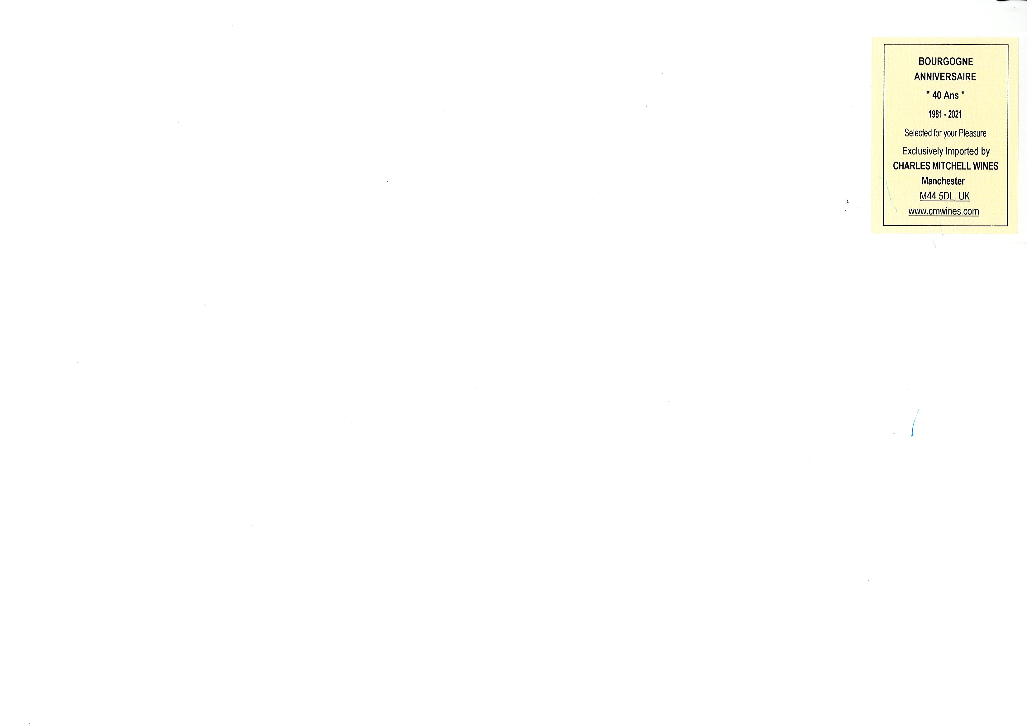

### > Grape variety : 100% Bourgogne Chardonnay – planted in 1959.

### Twelve months in Allier barrique – (25% nouveau et 75% deuxième)

### > Climat : The most prestige single vineyard "La Fosse" is a natural hollow, which is the source of the River Thalie with prime south east facing exposure

### > Terroir :Clay-limestone in the middle of the rich slopes with very deep roots.

### Totally organic with full respect of nature and hand-picked selected grapes.

### 

> Bouquet : Fragrant and enticing with exotic aromas of ripe fruits underlined by mineral overstones – extremely seductive….

> Palate : Sensuous mouthfeel with a perfect balance between the crisp acidity and the voluptuous crescendo of ripe tropical fruits. A beautiful expression

Bourgogne “40 Ans” Anniversaire Drink now > 2030

Selected for your Pleasure and in celebration of 40 Vintage Years !

Limited edition 50 x12b cases available £599/12b

2018 Rully Premier Cru

La Fosse « 40 Ans »